Installing Documentation for Cloverleaf 19.1

The Cloverleaf documentation has been removed from the Cloverleaf install package. This includes the Cloverleaf Portable Client.

- Download from inforextreme.com, file name: HVI-CLIS_19010000_DOCUMENTATION.zip
- To install the online documentation, copy/paste the zip file to integrator\docs.
- Then, unzip the zip file clis_19.1.x_clfisolh_cl_en-us_oxyhelp7.zip in the same folder.
- Go to Server Administration (Administrator)
- Click on the Web Server tab. And select the following two options:
  - Launch web server on Host Server startup
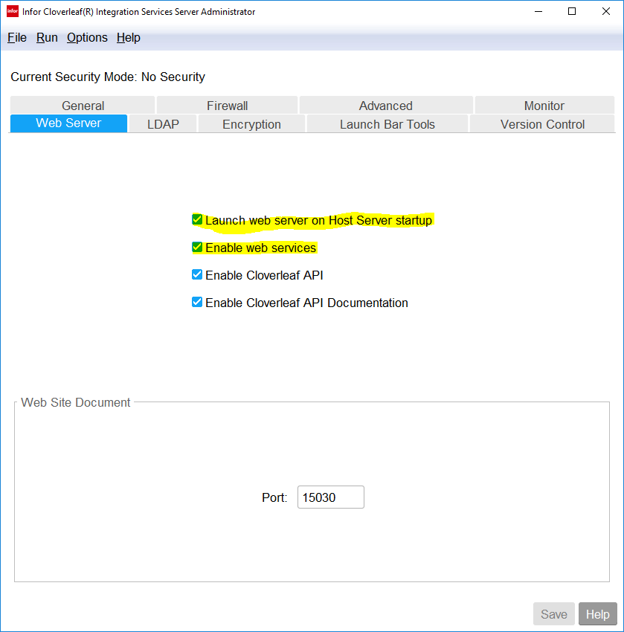
  - Enable web services

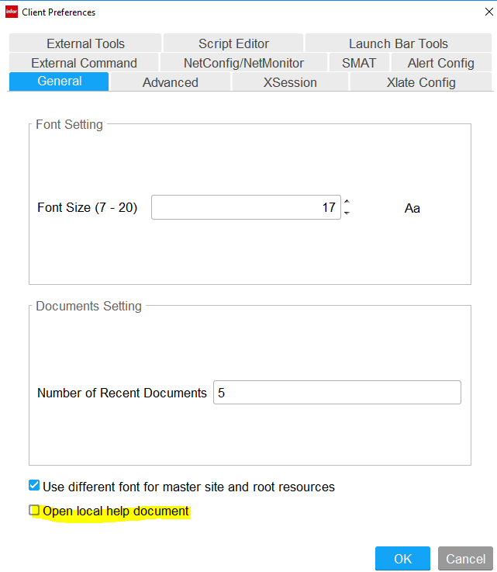
In the Client IDE, go to: Options => Client Preferences. Make sure that Open Local help document is unchecked.

- Bounce the host server, hciss -k h then hciss -s h
Warning: All clients will lose connection to the cloverleaf server, until the host server is started back up.

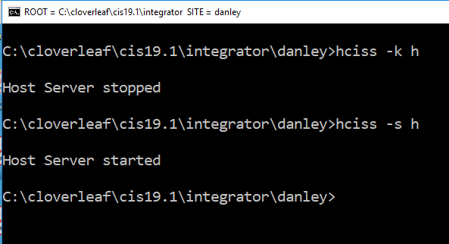

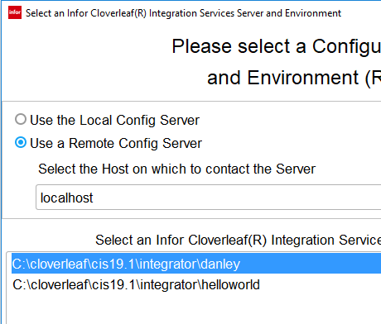
- Also make sure that your using Use a Remote Config Server.

